REG NO: 230701504  
NAME : KAAVIYA.R

DEPT : CSE – A SECTION

**DIVIDE AND CONQUER**

**QUESTION 3.A**

**AIM:**

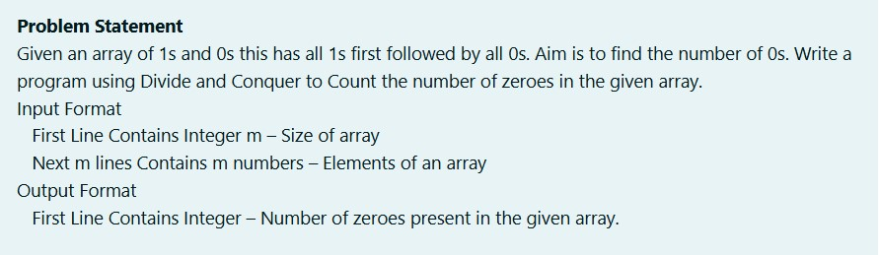

**ALGORITHM :**

Step 1: Start

Step 2: Input the integer n

Step 3: Initialize array a of size n

Step 4: For each index i from 0 to n-1, input a[i]

Step 5: Call the function countz(a, 0, n - 1) and store its result in count

Step 6: Print the value of count

Step 7: Stop

**PROGRAM :**

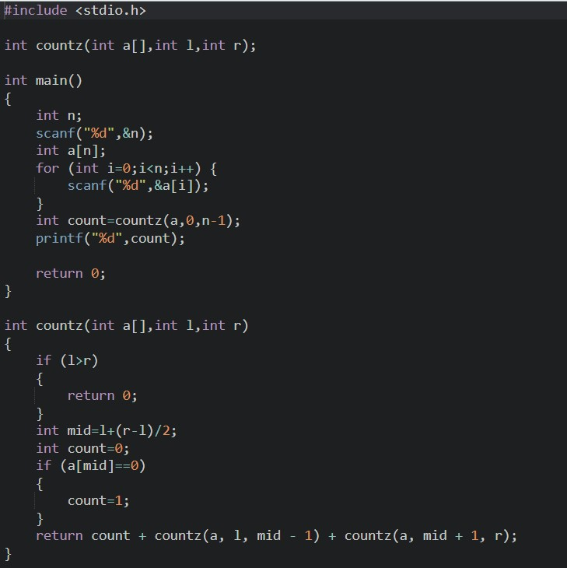

**OUTPUT:**

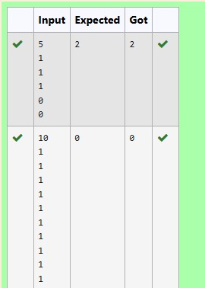

**RESULT :**

The above program is executed successfully .

**QUESTION 3.B**

**AIM :**

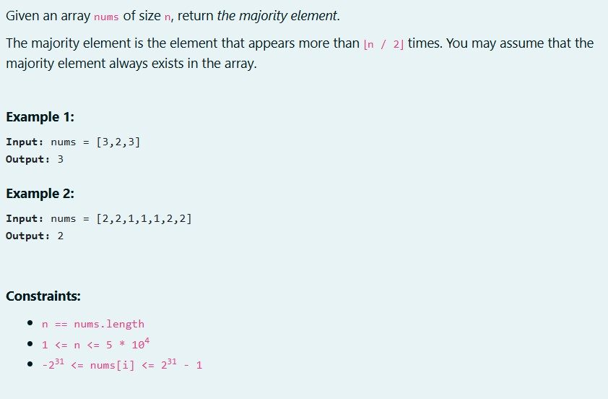

**ALOGORITHM :**

Step 1: Start

Step 2: Input the integer n

Step 3: Initialize array a of size n

Step 4: For each index i from 0 to n-1, input a[i]

Step 5: Call the function majority(a, 0, n - 1) and store its result in majoel

Step 6: If majoele is not -1, print majoele; otherwise, print "No Majority Element" Step 7: Stop

Step 8: If rc > (r - l + 1) / 2, return rightmajo

Step 9: Return -1

**PROGRAM :**

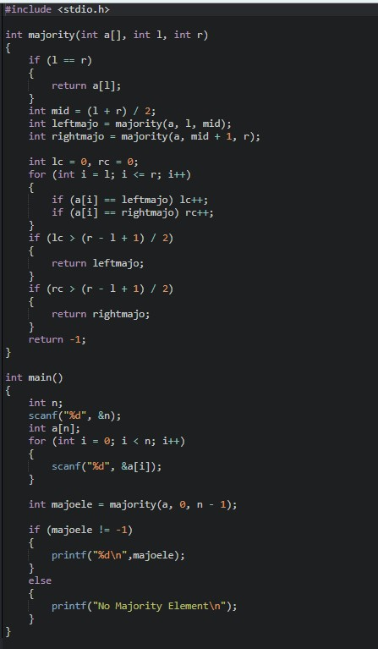

**OUTPUT :**

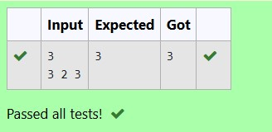

**RESULT :**

The above program is executed successfully.

**QUESTION 3.C**

**AIM :**

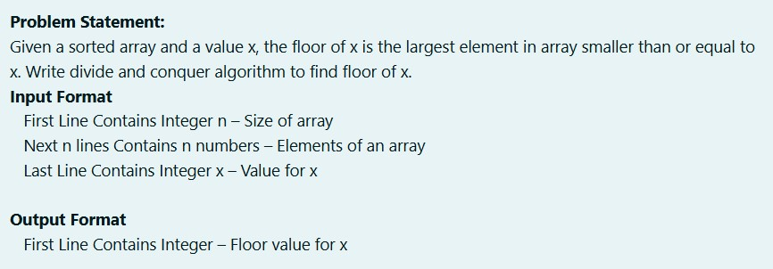

**ALGORITHM :**

Step 1: Start

Step 2: Input the integer n

Step 3: Initialize array a of size n

Step 4: For each index i from 0 to n-1, input a[i]

Step 5: Input integer k

Step 6: Call findfloor(a, 0, n - 1, k)

Step 7: Stop

**PROGRAM :**

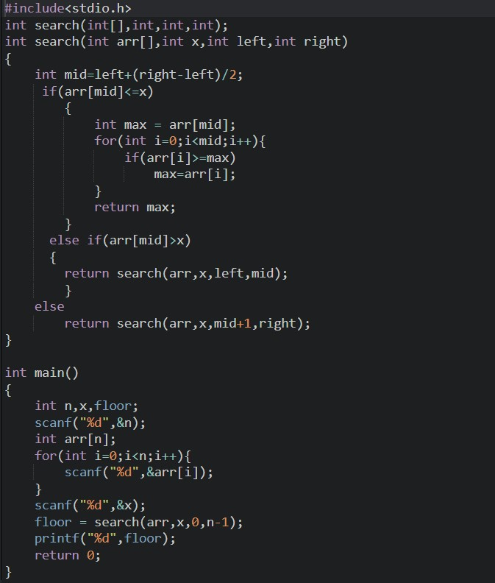

**OUTPUT:**

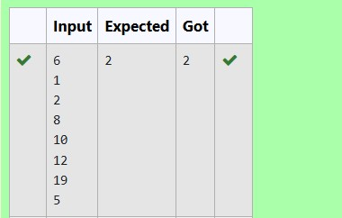

**RESULT:**

The above program is executed successfully.

**QUESTION 3.B**

**AIM :**

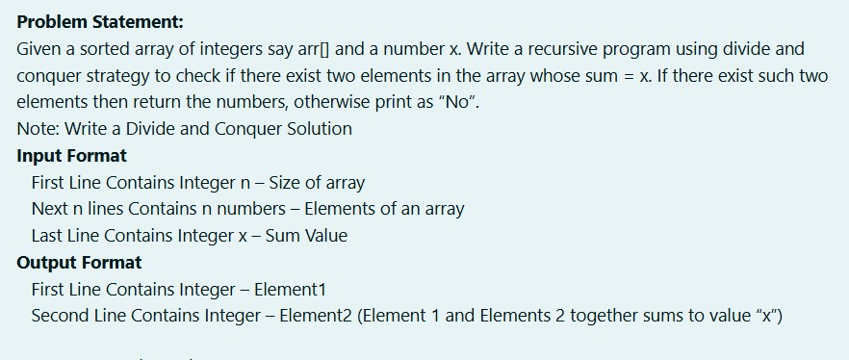

**ALGORITHM :**

Step 1: Start

Step 2: Input the integer n

Step 3: Initialize array arr of size n

Step 4: For each index i from 0 to n-1, input arr[i]

Step 5: Input integer x

Step 6: Call findPair(arr, 0, n - 1, x)

Step 7: Stop

**PROGRAM :**

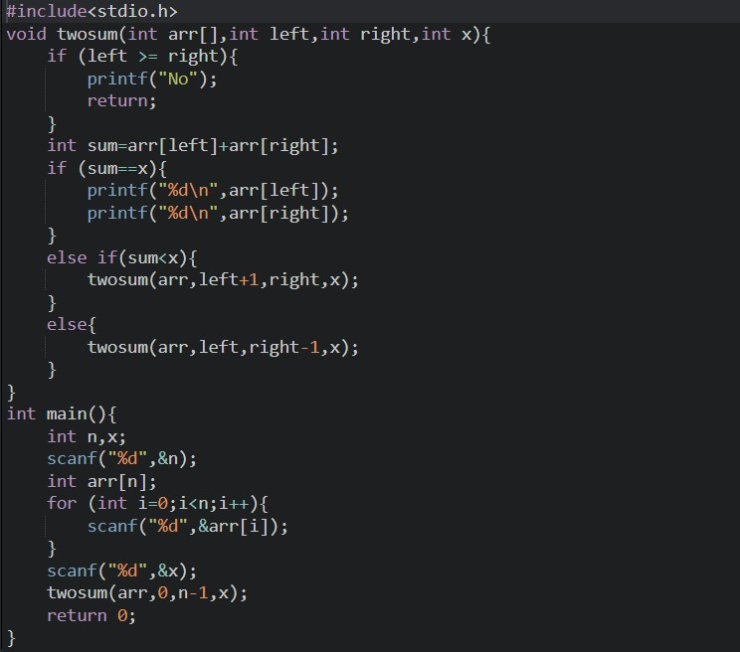

**OUTPUT:**

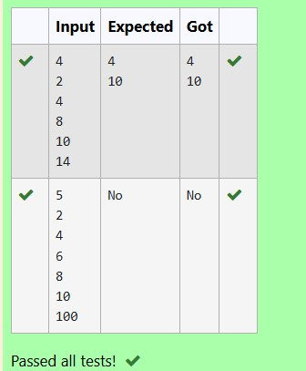

**RESULT:**

The above program is executed successfully.

**QUESTION 3.E**

**AIM:**

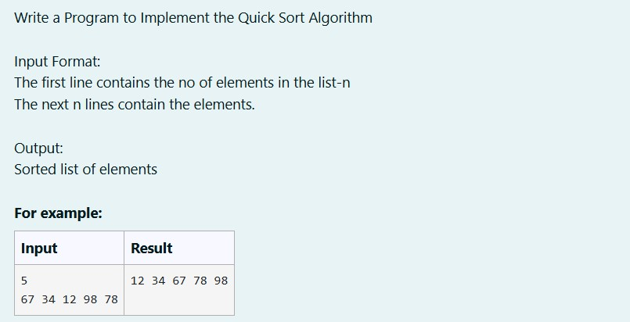

**ALGORITHM :**

Step 1: Start

Step 2: Input the integer n

Step 3: Initialize array arr of size n

Step 4: For each index i from 0 to n-1, input arr[i]

Step 5: Call quickSort(arr, 0, n - 1)

Step 6: For each index i from 0 to n-1, print arr[i] Step 7: Stop

**PROGRAM :**

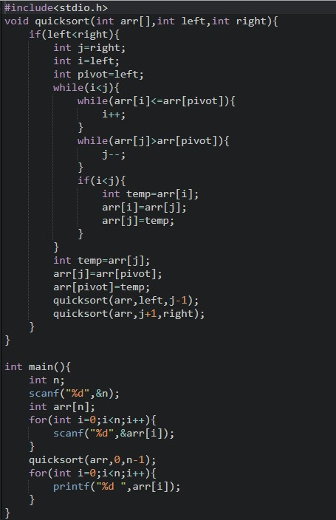

**OUTPUT :**

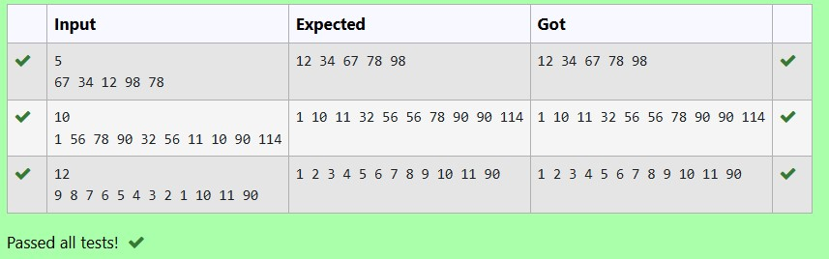

**RESULT:**

The above program is executed successfully